**___________________________________________________________________________**

Kerim Altınörs was born in 1981 in Neuss, Germany. He first studied flamenco guitar, then began studying classical guitar with Bülent Ergüden in 1999. He completed his classical guitar education in the Music Ensembles Undergraduate Program of the Faculty of Art and Design at Yıldız Technical University between 2004 and 2011. While studying, he undertook the role of assistant coordinator at the International Yıldız Guitar Days, of which Ergüden was the chief coordinator. Altınörs also performed solo and duo concerts at this festival. He attended Istanbul University State Conservatory in 2012, receiving his master’s degree with the thesis titled “A Methodological Approach to Technical Difficulties in Joaquin Rodrigo's Guitar Works” under the supervision of his academic advisor Erdem Sökmen. He completed his doctorate at YTU Faculty of Art and Design, under the supervision of Bülent Ergüden, with the study titled “A Comparative Analysis of The Guitar Transcrıptions of Isaac Albeniz’s Solo Piano Works From Romantic and Modern Perspectives” He attended several master classes of leading guitarists such as Thomas Müller-Pering, Marco Socias, Hopkinson Smith, Lorenzo Micheli, Carlo Marchione, David Russell, Lucio Matarazzo, Zoran Dukic, and Hubert Kappel at the Koblenz International Guitar Festival and Academy (Germany).

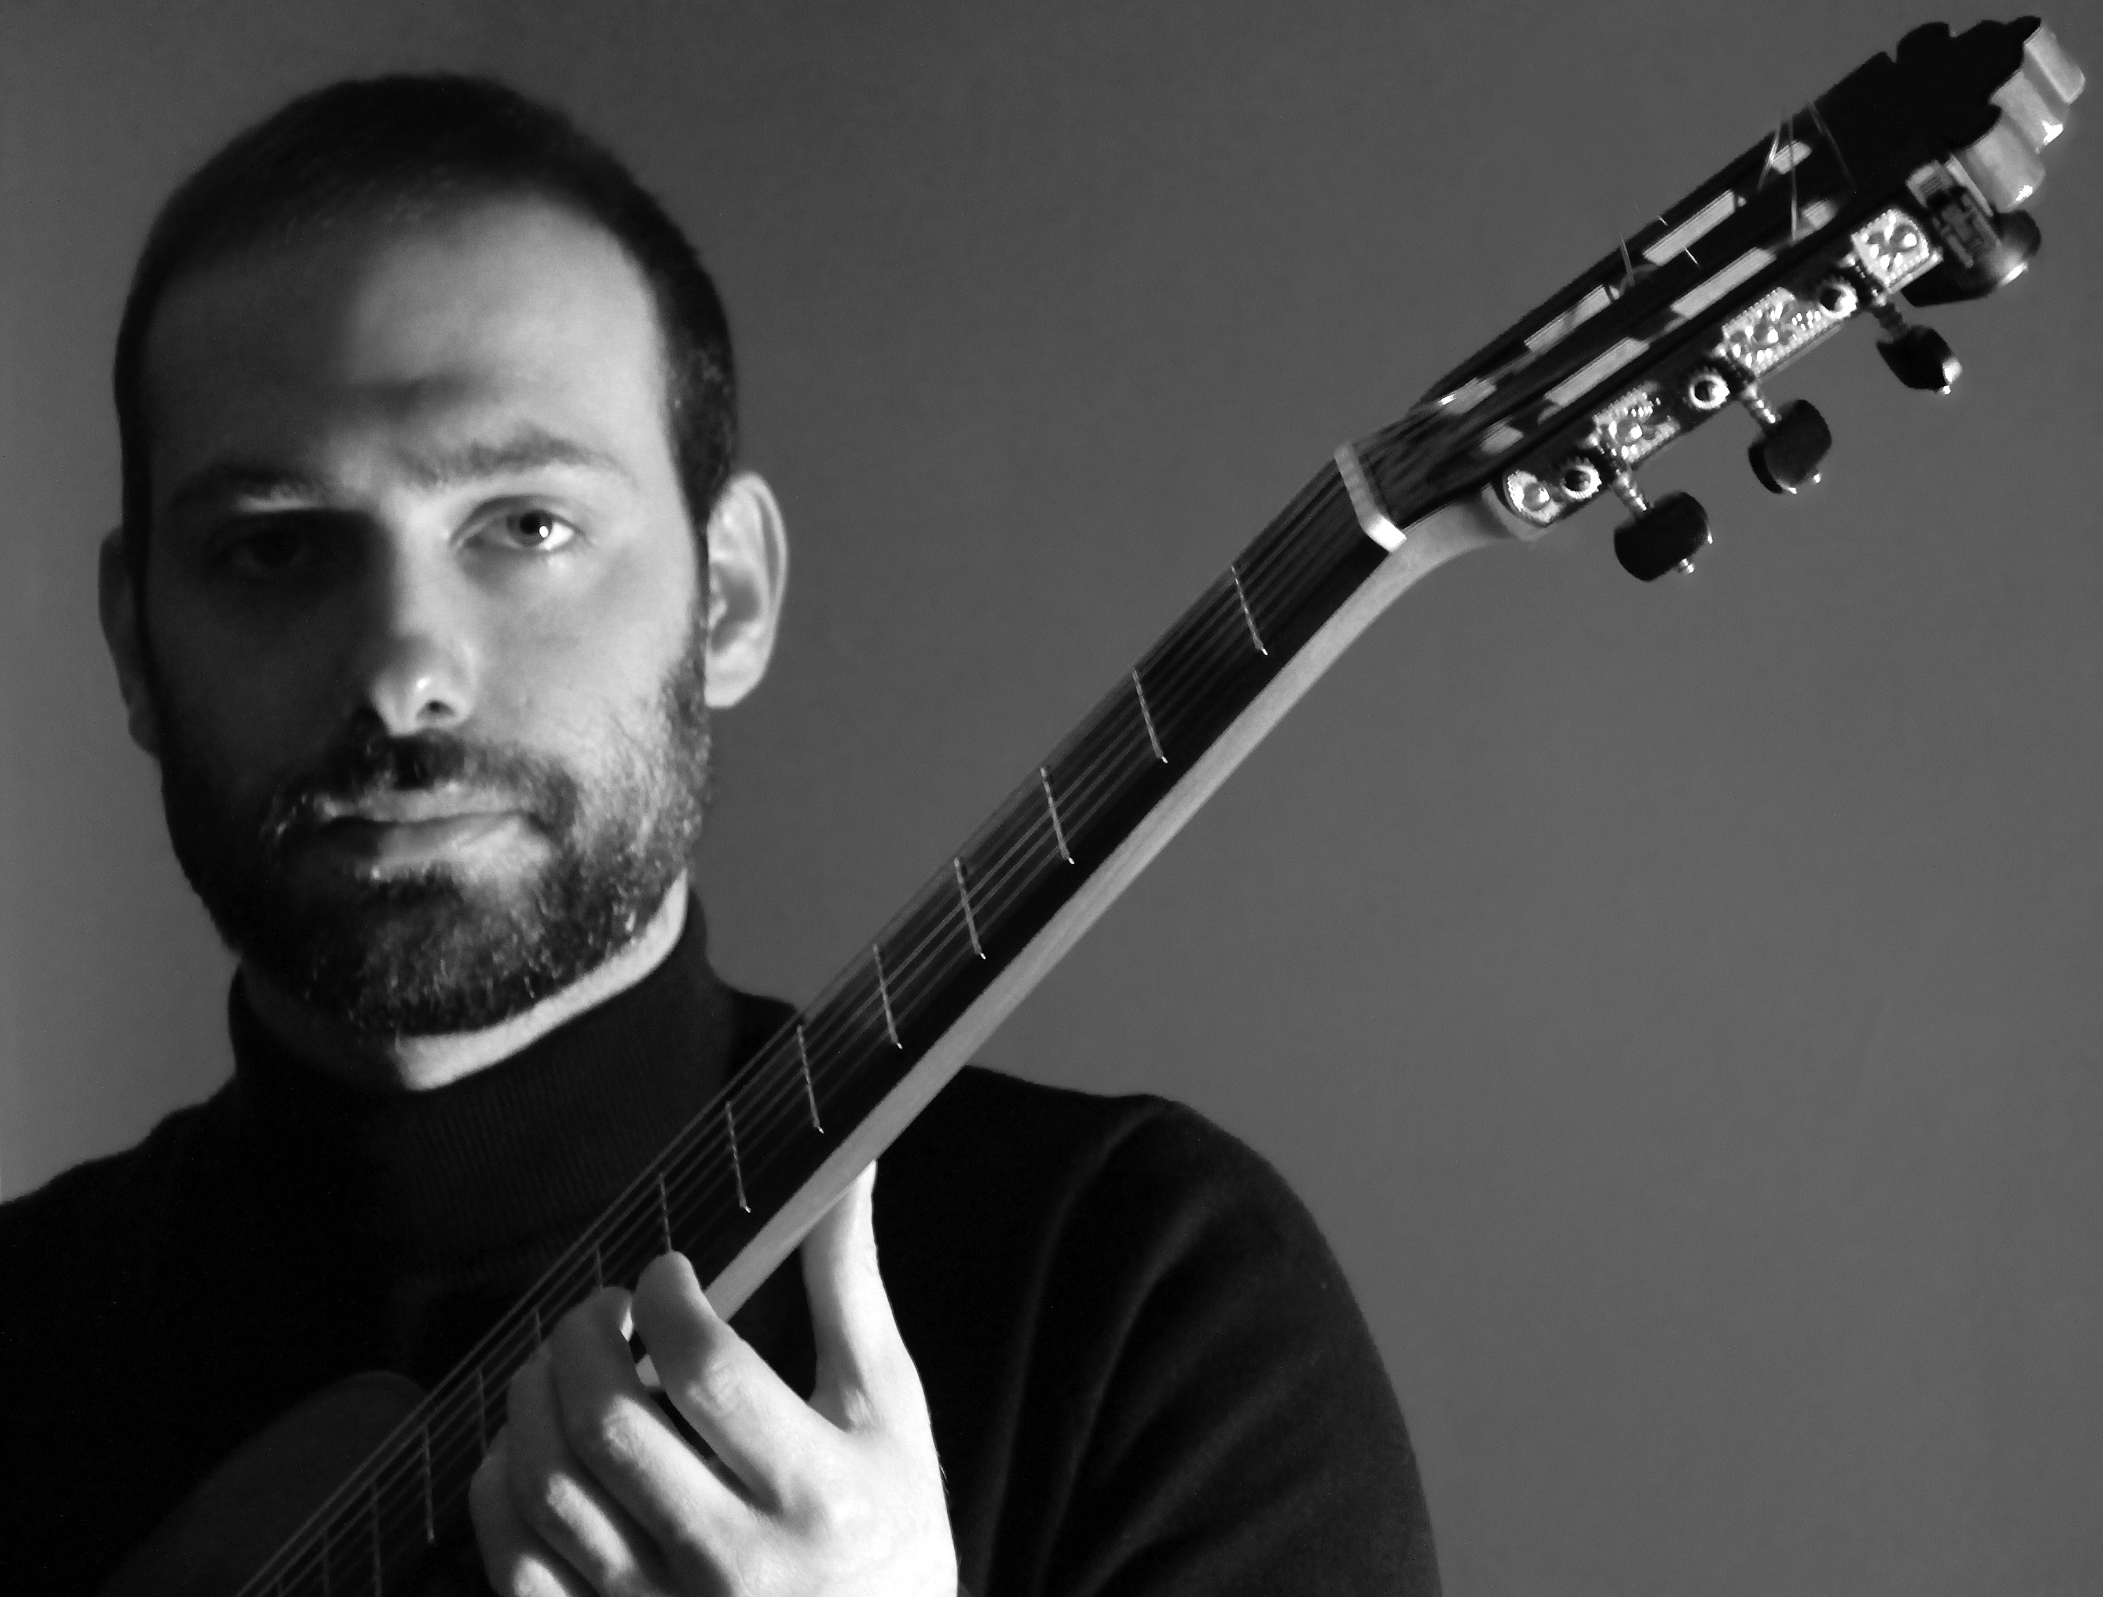

The Turkey Guitar Festival (2013), organized by Kağan Korad at Bilkent University, Altınörs performed one of the composer Eray Duzgunsoy’s works, called “Darfur Fragments,” which was recorded during the concert. In 2016, he conducted a detailed interview with Bill Piburn from the American journal 'Fingerstyle Guitar Journal,' where he published an edition of Andaluza by Eduardo Sainz de la Maza. In 2018, Victor Frost, an American composer, composed a valuable variation work titled “Variations Lyriques Op. 81,” which was dedicated to Altınörs. In the same year, Altınörs performed the opening concert of the Turkey Guitar Festival. He gave several master classes and seminars at the Middle East Technical University, Bilkent University, Ankara Music and Fine Arts University, and various festivals, as well as served as a jury in musical competitions. His album called “Altınörs Plays," featuring valuable works by composers such as Domenico Scarlatti, Isaac Albéniz, Joaquin Rodrigo, and E. Sainz de la Maza was released in 2021. His pieces from this album were broadcast on top radio stations such as TRT and Borusan Classic. Altınörs taught at Okan University Conservatory between 2017 and 2022. Since 2017, he has been working as a lecturer at Yıldız Technical University, Faculty of Art and Design.

**___________________________________________________________________________**